Nama : Maulana Yusuf

NIM : 17090096

Kelas : 5B

Praktikum 2

- Source Code

view-latihan.php → application/views
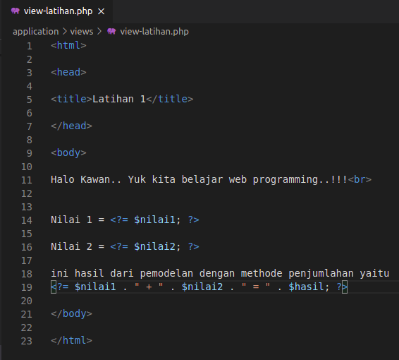

Latihan1.php → application/controllers
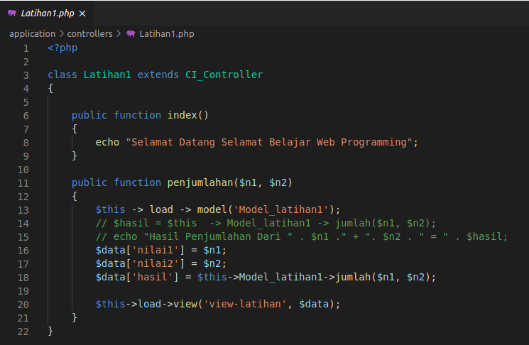

Model_latihan1.php → application/models
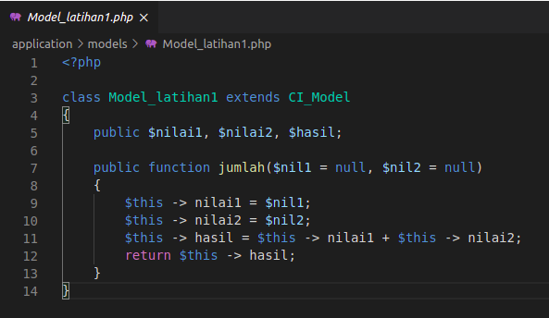

.htaccess → pustaka-booking
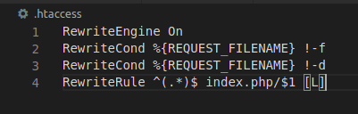

- Hasil URL

http://localhost/pustaka-booking/latihan1/penjumlahan/4/6

- Capture Hasil

